**Experiment 2: Finding Largest and Smallest Values**

**(a) Find Largest Number from an Array**

**Aim**

To find the largest number from an array using 8085 microprocessor.

**Apparatus Required**

* 8085 Simulator
* PC

**Algorithm**

1. Start the program.
2. Initialize a memory pointer (using HL register pair) to point to the starting address of the array.
3. Load the count of numbers in the array into a register (say, register B).
4. Increment the memory pointer to point to the first data element.
5. Load the first element into the Accumulator (A) – this is the initial largest number.
6. Decrement the count by 1 since the first number is already considered.
7. Repeat the following steps until the count becomes 0:  
   * Increment the memory pointer to move to the next element.
   * Compare the current memory element with the value in Accumulator.
   * If the current element is greater than the Accumulator content:  
     + Move the current element into the Accumulator (update the largest).
   * Decrement the count.
8. After all elements are checked, the Accumulator will contain the largest number.
9. Store the content of the Accumulator (i.e., the largest number) in memory at the required address.
10. End the program.

**Program**

; Program to find the greatest number using I/O Ports

IN 01H ; Read first number

MOV D, A ; Assume first number is greatest

IN 02H ; Read second number

CMP D

JC NEXT2 ; If A < D, skip update

MOV D, A ; Else update greatest

NEXT2:

IN 03H ; Read third number

CMP D

JC NEXT3

MOV D, A

NEXT3:

IN 04H ; Read fourth number

CMP D

JC NEXT4

MOV D, A

NEXT4:

IN 05H ; Read fifth number

CMP D

JC DONE

MOV D, A

DONE: MOV A, D

OUT 06H ; Output greatest number at port 06H

HLT

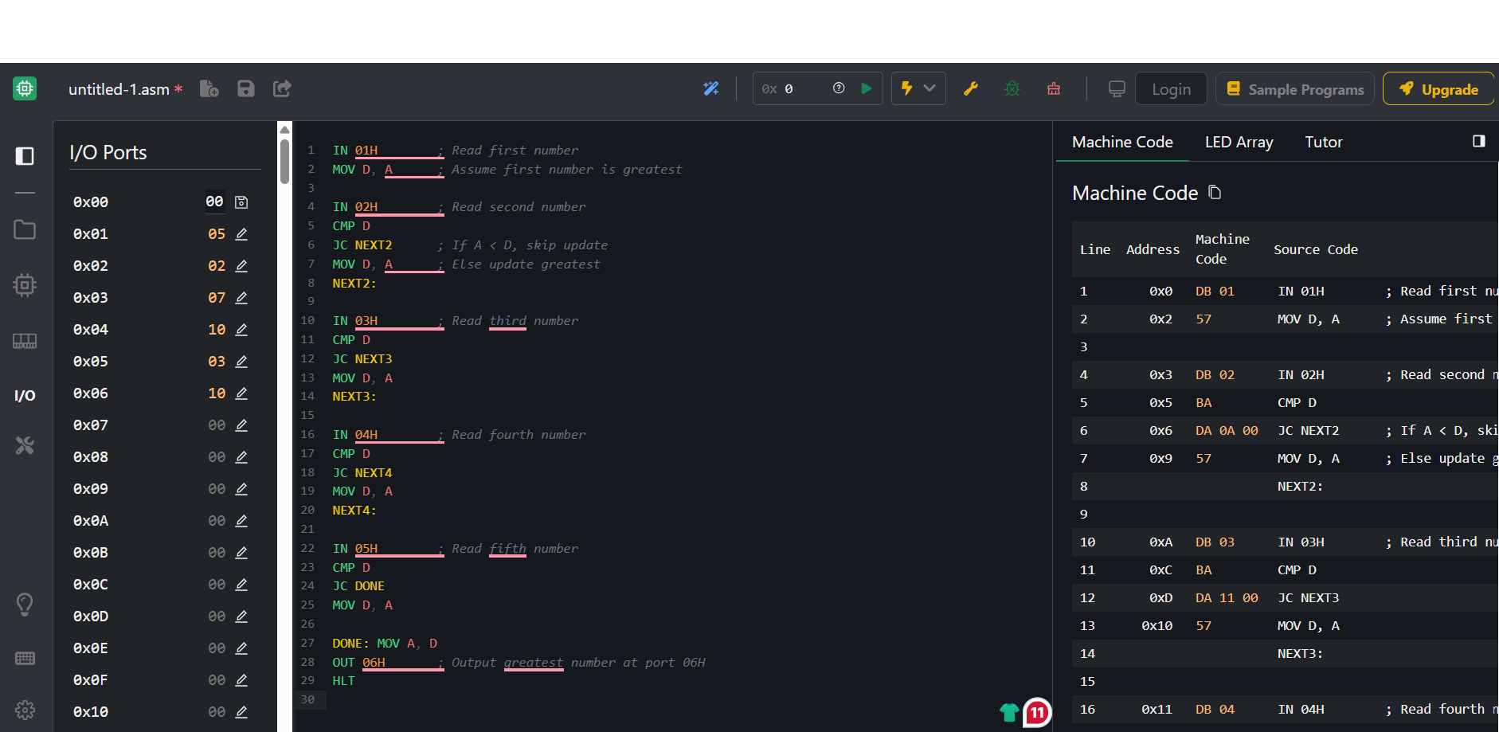

**Input Ports (numbers are read from these ports):**

* 01H → First number
* 02H → Second number
* 03H → Third number
* 04H → Fourth number
* 05H → Fifth number

**Output Port:**

* 06H → Greatest number

**Result**

Thus, the program to find the **largest number in an array** was executed successfully.

**Find Smallest Number from an Array**

**Aim**

To find the smallest number from an array using 8085 microprocessor.

**Apparatus Required**

* 8085 Simulator
* PC

**Algorithm**

1. Start the program.
2. Initialize the HL register pair to point to the starting address of the array.
3. Load the count of elements from memory into a register (e.g., register B).
4. Increment HL to point to the first data element.
5. Load the first data into the Accumulator (A) – assume this is the smallest number initially.
6. Decrement the count (B) by 1 because the first number is already loaded.
7. Repeat the following steps until the count becomes 0:  
   * Increment HL to point to the next data element.
   * Compare the content of memory (M) with the Accumulator (A).
   * If **M < A**, move M to Accumulator (update the smallest number).
   * Decrement the count (B).
8. After the loop ends, the Accumulator holds the smallest number.
9. Store the content of the Accumulator in a desired memory location (e.g., 4300H).
10. End the program.

**Program**

; Program to find the smallest number using I/O Ports

IN 01H ; Read first number

MOV D, A ; Assume first number is smallest

IN 02H ; Read second number

CMP D

JNC NEXT2 ; If A >= D, skip update

MOV D, A ; Else update smallest

NEXT2:

IN 03H ; Read third number

CMP D

JNC NEXT3

MOV D, A

NEXT3:

IN 04H ; Read fourth number

CMP D

JNC NEXT4

MOV D, A

NEXT4:

IN 05H ; Read fifth number

CMP D

JNC DONE

MOV D, A

DONE: MOV A, D

OUT 07H ; Output smallest number at port 07H

HLT



**Input Ports (numbers are read from these ports):**

* 01H → First number
* 02H → Second number
* 03H → Third number
* 04H → Fourth number
* 05H → Fifth number

**Output Port:**

* 06H → Smallest number

**Result**

Thus, the program to find the **smallest number in an array** was executed successfully.